**Case Study 2**

**Profile of M/s VSC Pvt Ltd**

|  |  |
| --- | --- |
| **Name of Enterprise** | **M/S VSC Pvt Ltd** |
| **Director** | 1. Shri. MSC  2. Shri. G  3. Shri. M |
| **Constitution** | Private Limited Company |
| **Factory Address** | Hyderabad |
| **Established** | 2012 |
| **Line of activity** | Manufacturing of Ceramic SWG Pipes |
| **Udyog Aadhaar/SSI Registration No.** |  |
| **GST** |  |

1. **Line of Activity:**

Entrepreneur engaged in manufacturing of Ceramic SWG Pipes and supplies these products to government and private construction projects.

1. **Managerial Competencies**:
2. Sri G, Director of the company is having 24 years of experience in the same line of activity. He worked as a Director in M/s MC Pvt Ltd for a period of 15 years and presently one of the directors of M/s VSP Private Limited since, 2009. He is also a partner of M/s VSC All the units are in the same line of activity. He is Director in M/s VAB Pvt Ltd., which is manufacturers of AAC bricksm, from 2015. He is having 24 years of experience in manufacturing and sales.
3. Sri MSC, Director of the company and Managing Director in M/s VAB Pvt Ltd from 2015 and worked as Director of M/s. MC Pvt Ltd and he is one of the directors of M/s VSP Pvt Ltd. He is also a partner of M/s VSC. He is having 19 years of experience in manufacturing and sales.

1. Sri M, Director of the company is having 14 years of experience in manufacturing and sales of similar products. He is one of the directors of M/s VSP Ltd and a partner of M/s VSC since 2005 and one of the Directors in M/s VAB Pvt Ltd which is manufacturers of AAC bricks from 2015
2. **Manufacturing Process/Machinery:**

The raw material used is soil which is available in domestic market. The machinery used are Clay mixing machine, Molding machine, Kiln, Dryer and Cooling cabins. The area of the unit is 50,000 square feet. The unit is well maintained and rooms for residence are allocated to the employees outside the shed. There is quality control lab where the products are inspected by external experts. All the products are ISI compliant. The soil is dumped into clay mixing machine and turned into clay. This clay is shifted to another machine where it molds the clay into required shapes. After molding, the pipes are kept in a kiln for specified time to heat and become harder. Later, those pipes will be put up to dry and shifted to cooling cabins for final product. The products are in various sizes from 2 feet to 6 feet. The production capacity is 1000 tons per month at 100 percent capacity.

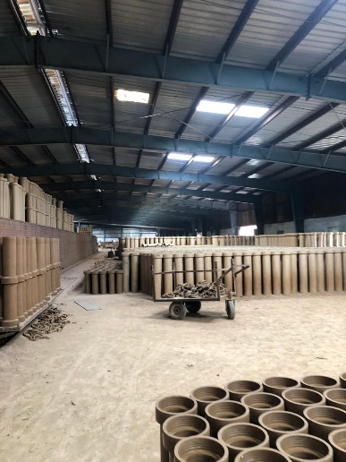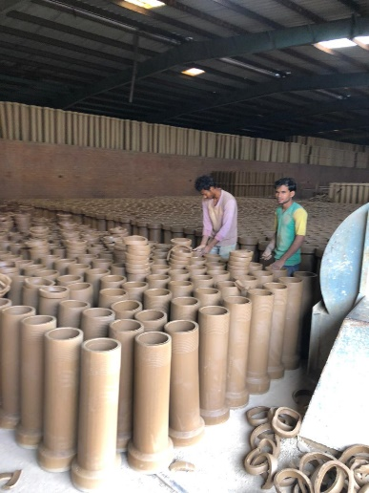

* **M/S VSC Pvt Ltd**

1. **Marketing:**

* Enterprise has good potential in domestic market not only in Telangana State but also in other states of the country like Karnataka.
* Supplies the products to government and private construction projects. The firm also executes orders for government departments like HMWSSB.
* Buyers are contractors of government projects and private construction parties
* As the unit is well established, there is no separate marketing arrangements other than brand reputation and customer influence.

1. **TIHCL intervention:**

The client has approached TIHCL for bridge finance against unreleased sanctioned incentives to repay overdues with SFC.

The unit was sanctioned a TL of ₹43 million, while only an amount Rs.32.5 million was released by State Financial Corporation. During last year unit is struggling for repayment of installments due to decline in the turnover and delay in receivables which made the account NPA in SFC. During this time term lender has initiated proceedings under SARFAESI ACT, 2002.

Enterprise was sanctioned with investment subsidy of ₹2.00 million in the year 2017 but not released till date. So, he approached TIHCL for Bridge Finance.

TIHCL has carried out the diagnostic study of the enterprise and identified following reasons for sickness

* Introduction of Demonetization and GST had negative impact on turnover of the enterprise.
* Delay in receivables from customers due to cash crunch in the market and by other govt policies
* As they have a long relationship with their customers, enterprise could not put the pressure on them for payment of bills.
* Most of the sales are towards contractors dealing with govt projects
* High Debt burden of Term Loan EMIs and higher interest rate.
* Since most of the buyers were from government projects, the credit period was little long in last one year compared to previous years.

As per TIHCL resolution package, enterprise was sanctioned and amount of ₹1.5 million as bridge finance. This bridge finance helped the unit to come out of the stress from SFC (Primary lender) and account was regularized by SFC. Hence, enterprise got relaxation from irregularities and able to manage cash flows at present.

|  |  |  |
| --- | --- | --- |
| **Key indicators** | **Pre-Revival** | **Post TIHCL intervention** |
| No of EMIs pending with primary lender | 8 | 0 |
| Capacity Utilization | 50% | 65% |
| Turnover | ₹26.7 million | ₹35.6 million |
| Employment | 15 | 23 |

1. **Labor Status: (post TIHCL intervention)**

|  |  |  |
| --- | --- | --- |
| Gender | Skilled | Unskilled |
| Men | 15 | 3 |
| Women | 5 | 0 |
| Total | 20 | 3 |

**Livelihood:**

Enterprise created employment to 23 workers at 65% of capacity and may require another 8 workers during full capacity.